Data in table is taken from FluView, <https://gis.cdc.gov/grasp/fluview/fluportaldashboard.html>.

NATIONAL FORECAST

Note: The epidemiological curve below is zoomed in to recent and upcoming weeks.

|  |  |
| --- | --- |
| WEEK | WEIGHTED ILI% |
| 44 | 2.041 |
| 45 | 2.394 |
| 46 | 2.630 |
| 47 | 2.893 |
| 48 | 3.406 |
| 49 | 3.258 |
| 50 | 3.944 |
| 51 | 5.081 |
| 52 | 7.085 |
| 1 | 5.958 |
| 2 | 4.964 |
| 3 | 5.343 |
| 4 | 5.945 |
| 5 | 6.654 |
| 6 | 6.722 |
| 7 | 6.051 |
| 8 | 5.467 |
| 9 | 5.265 |
| 1 – one week ahead - What do I think? 10 |  |
| 2 – two weeks ahead - What do I think? 11 |  |
| 3 – three weeks ahead - What do I think? 12 |  |
| 4 – four weeks ahead – What do I think? 13 |  |
| Flu Onset – when do I think it will first go above baseline of 2.4 for three consecutive weeks? |  |
| Season Peak - In what week do I think it will peak? |  |
| Max Peak – What do I think the max will be? |  |

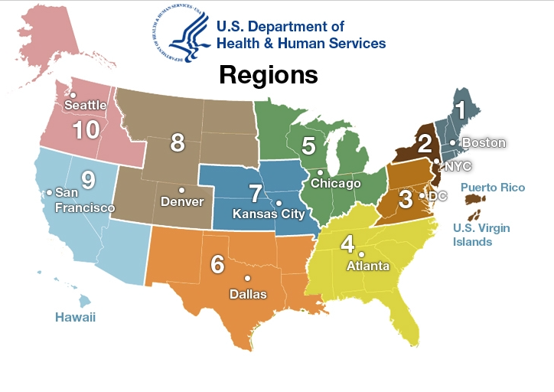

National Baseline 2.4%

Region 1 Baseline 1.9%

Region 2 Baseline 3.2%

Region 3 Baseline 1.9%

Region 4 Baseline 2.4%

Region 5 Baseline 1.9%

Region 6 Baseline 3.8%

Region 7 Baseline 1.7%

Region 8 Baseline 2.7%

Region 9 Baseline 2.4%

Region 10 Baseline 1.5%

REGION 3 FORECAST (Delaware, Maryland, Pennsylvania, Virginia, Washington D.C., and West Virginia)

Note: The epidemiological curve below is zoomed in to recent and upcoming weeks.

|  |  |
| --- | --- |
| WEEK | WEIGHTED ILI% |
| 45 | 1.694 |
| 46 | 1.868 |
| 47 | 2.059 |
| 48 | 2.391 |
| 49 | 2.448 |
| 50 | 3.008 |
| 51 | 3.952 |
| 52 | 5.691 |
| 1 | 5.539 |
| 2 | 4.439 |
| 3 | 4.663 |
| 4 | 5.320 |
| 5 | 6.359 |
| 6 | 6.546 |
| 7 | 5.826 |
| 8 | 5.276 |
| 9 | 5.156 |
| 1 – one week ahead - What do I think? 10 |  |
| 2 – two weeks ahead - What do I think? 11 |  |
| 3 – three weeks ahead - What do I think? 12 |  |
| 4 – four weeks ahead – What do I think? 13 |  |
| Flu Onset – when do I think it will first go above baseline of 1.9 for three consecutive weeks? |  |
| Season Peak - In what week do I think it will peak? |  |
| Max Peak – What do I think the max will be? |  |

GEORGIA FORECAST

Note: The epidemiological curve below is zoomed in to recent and upcoming weeks.

|  |  |
| --- | --- |
| WEEK | WEIGHTED ILI% |
| 48 | 5.741 |
| 49 | 5.170 |
| 50 | 6.628 |
| 51 | 9.524 |
| 52 | 12.266 |
| 1 | 9.408 |
| 2 | 6.959 |
| 3 | 6.761 |
| 4 | 6.602 |
| 5 | 7.988 |
| 6 | 7.745 |
| 7 | 6.087 |
| 8 | 5.258 |
| 9 | 4.645 |
| 1 – one week ahead - What do I think? 10 |  |
| 2 – two weeks ahead - What do I think? 11 |  |
| 3 – three weeks ahead - What do I think? 12 |  |
| 4 – four weeks ahead – What do I think? 13 |  |
| Season Peak - In what week do I think it will peak? |  |
| Max Peak – What do I think the max will be? |  |

MINNESOTA FORECAST

Note: The epidemiological curve below is zoomed in to recent and upcoming weeks.

|  |  |
| --- | --- |
| WEEK | WEIGHTED ILI% |
| 48 | 4.059 |
| 49 | 3.530 |
| 50 | 3.536 |
| 51 | 5.651 |
| 52 | 9.711 |
| 1 | 5.491 |
| 2 | 2.868 |
| 3 | 3.150 |
| 4 | 4.129 |
| 5 | 4.333 |
| 6 | 5.213 |
| 7 | 6.212 |
| 8 | 4.900 |
| 9 | 4.618 |
| 1 – one week ahead - What do I think? 10 |  |
| 2 – two weeks ahead - What do I think? 11 |  |
| 3 – three weeks ahead - What do I think? 12 |  |
| 4 – four weeks ahead – What do I think? 13 |  |
| Season Peak - In what week do I think it will peak? |  |
| Max Peak – What do I think the max will be? |  |